# CS 255 System Design Document

**Christopher Gauthier**

## UML Diagrams

### UML Use Case Diagram

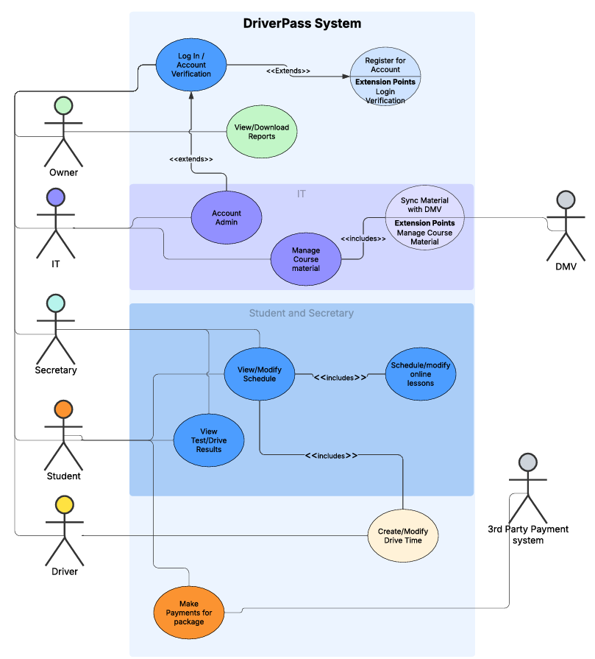

### UML Activity Diagrams

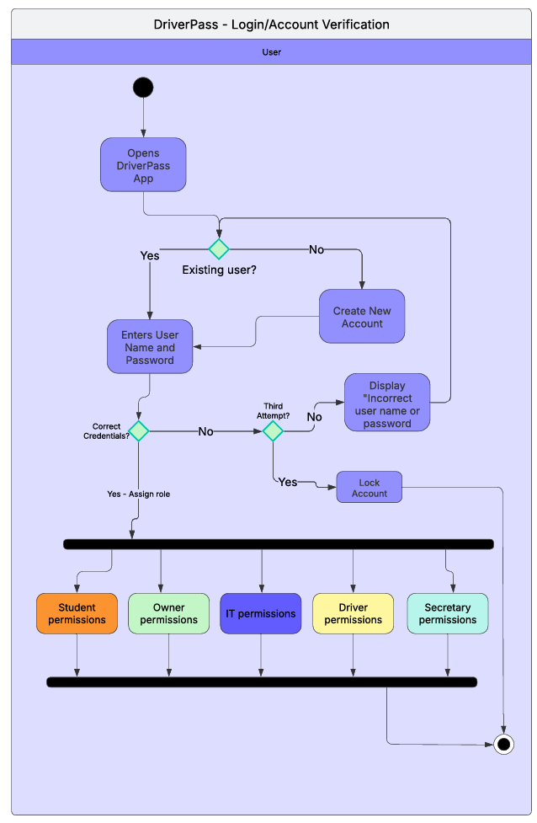

1 of 2

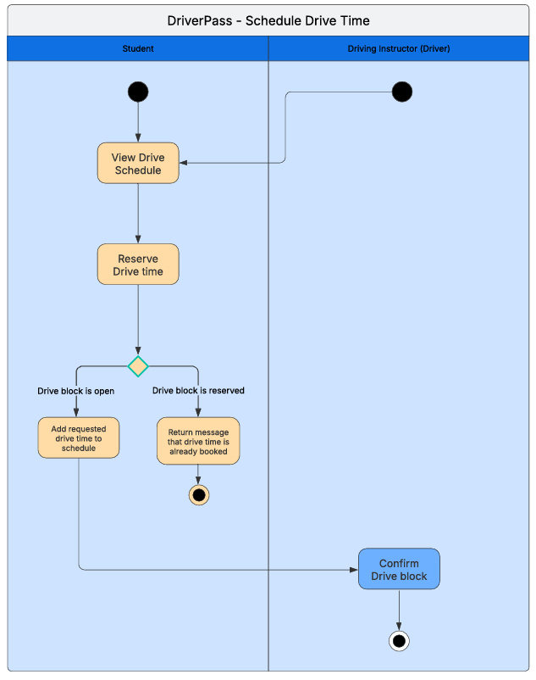

2 of 2

### UML Sequence Diagram

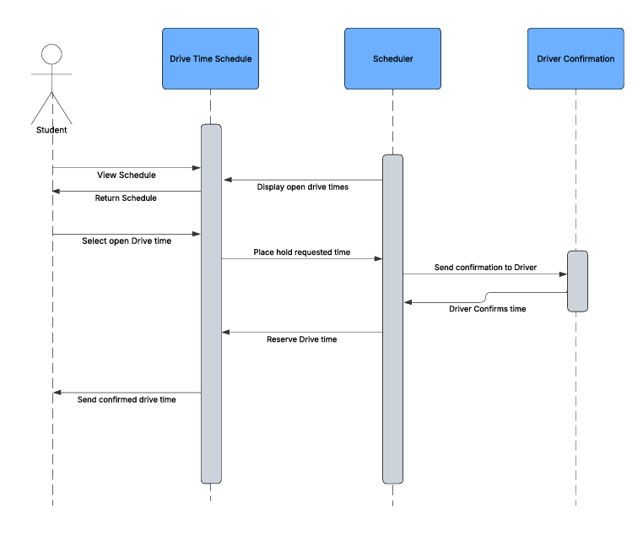

### UML Class Diagram

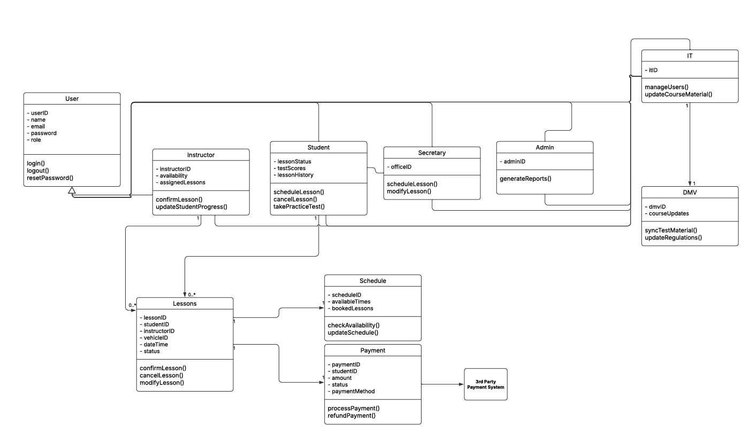

## Technical Requirements

Technical requirements cover a range of needs. To start, a cloud environment such as Amazon Web Services (AWS), or Microsoft’s Azure will be needed for server infrastructure. With 3rd party cloud hosting, ensuring processing power and memory management is available and scalable will allow dozens to hundreds of users to be on the system at any given time. Additionally, robust storage is needed to maintain backups of the system and data. Starting with at least 1TB should suffice.

For client-side requirements any modern MacOS, iOS, Android, or Microsoft device will meet the needs of the user. Ensuring updated operating systems and browsers will ensure proper functionality and security.

Software requirements will include a preferred server-side OS such as Ubuntu (Linux) or Windows Server, as well as a database framework such as mySQL.

Several APIs will need to be connected as well. APIs for a DMV connection, payment gateway, and email/notification services.

Tools for development will require project management tools and team collaboration tools, Asana, MSTeams or Jira are viable options, in addition to more general use collaboration tools like Slack.

On site, an internet connection will be required with wifi coverage for users and admin to access the system remotely.